EXPERIMENT 4,5

MEDIAN GAMMA POWER   
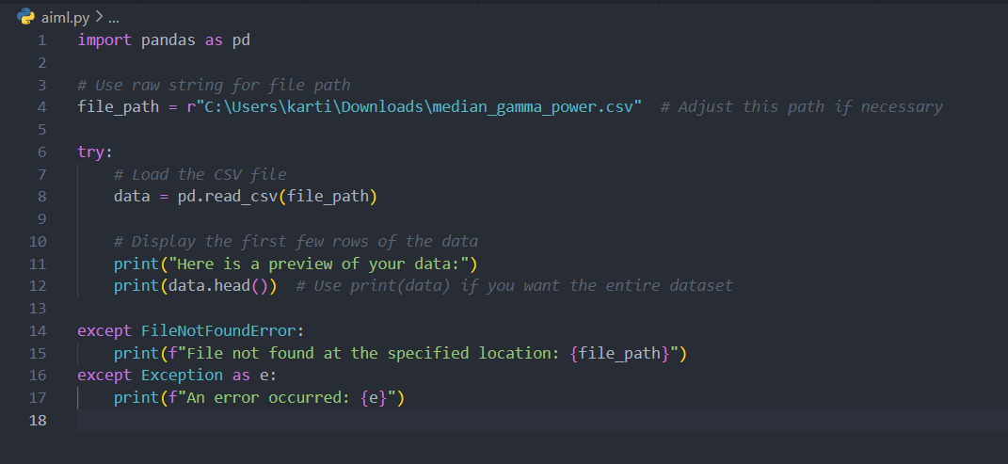

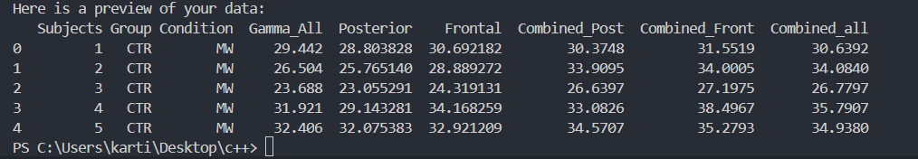

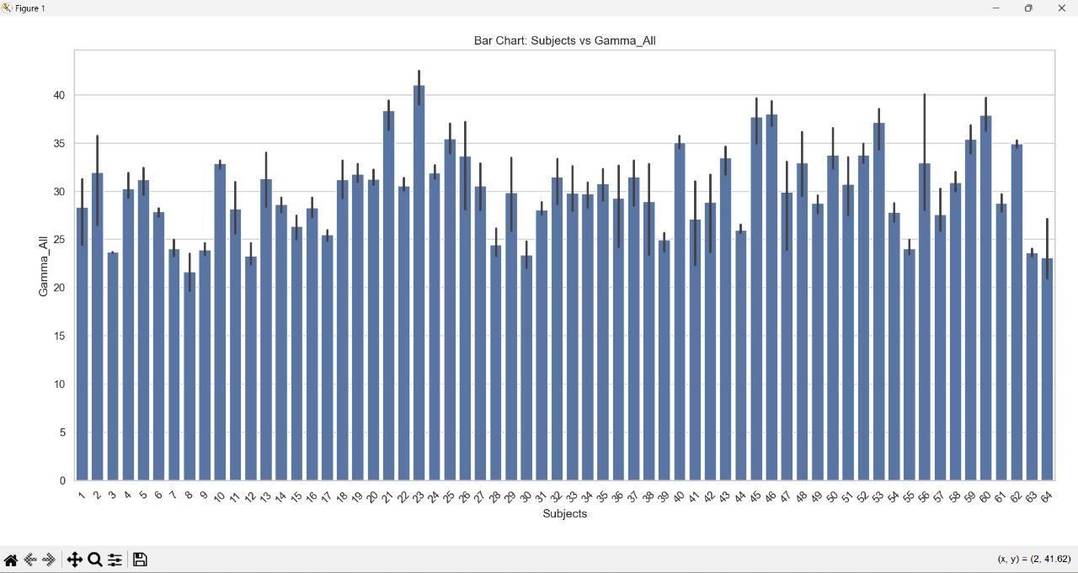

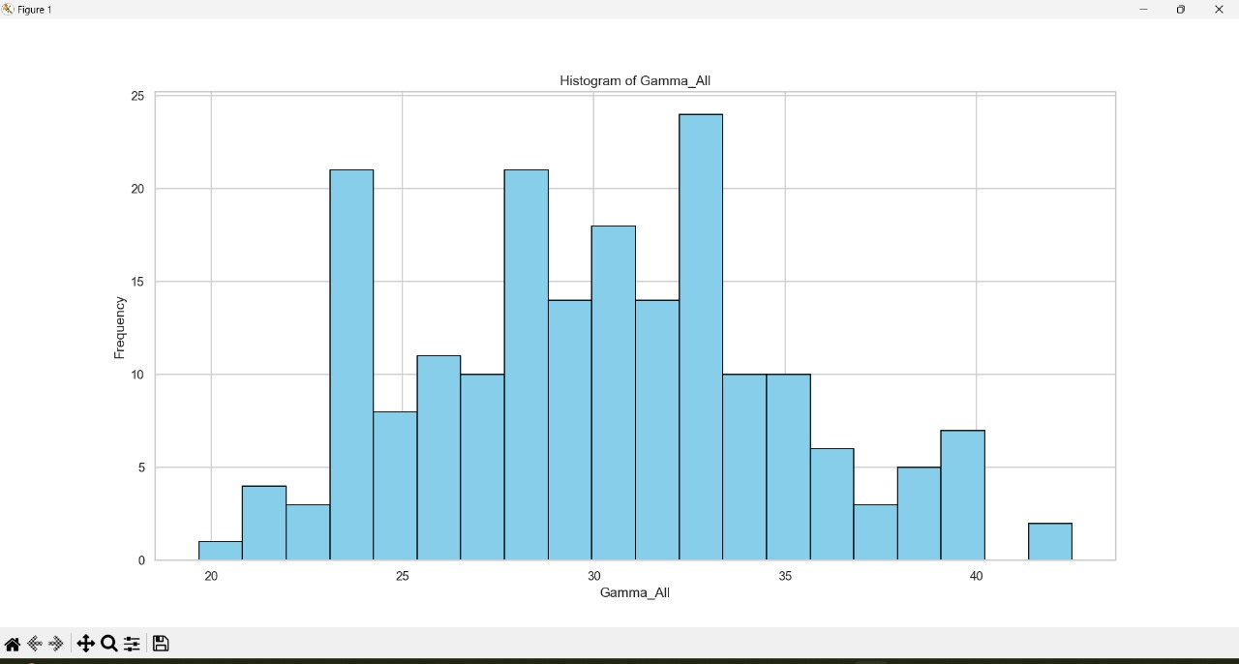

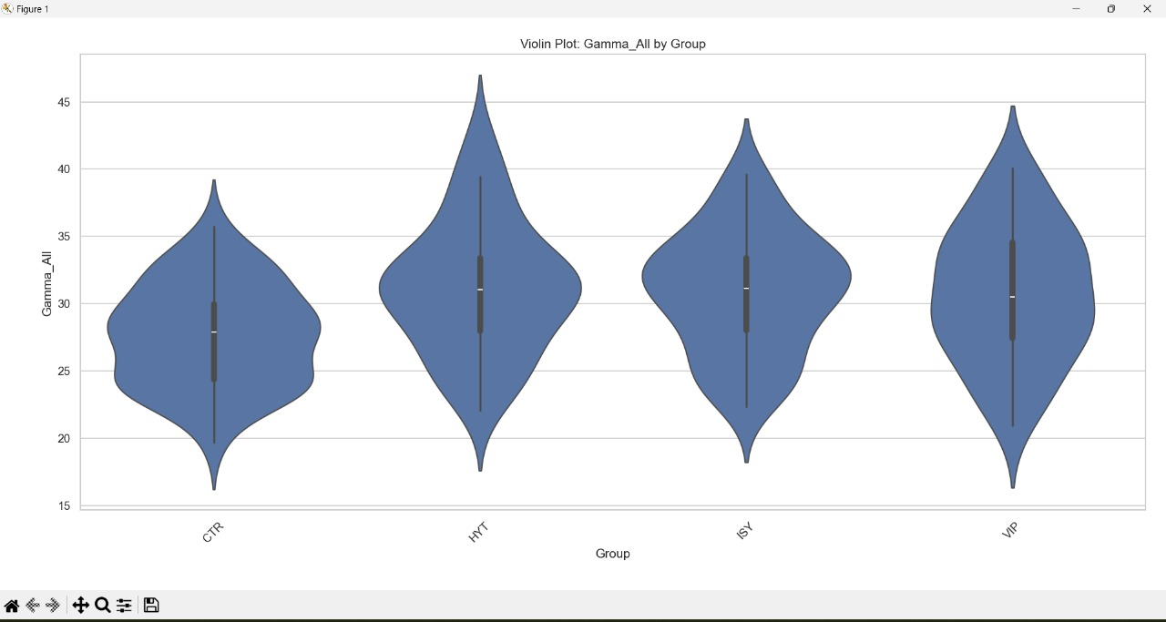

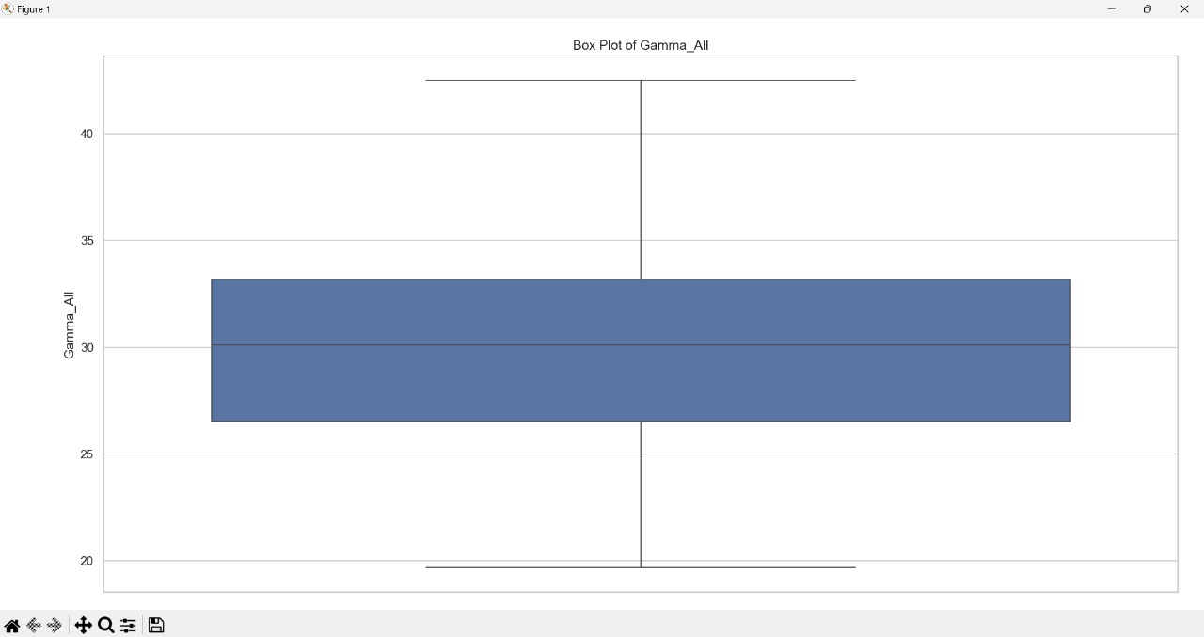

MEDIAN ALPHA POWER

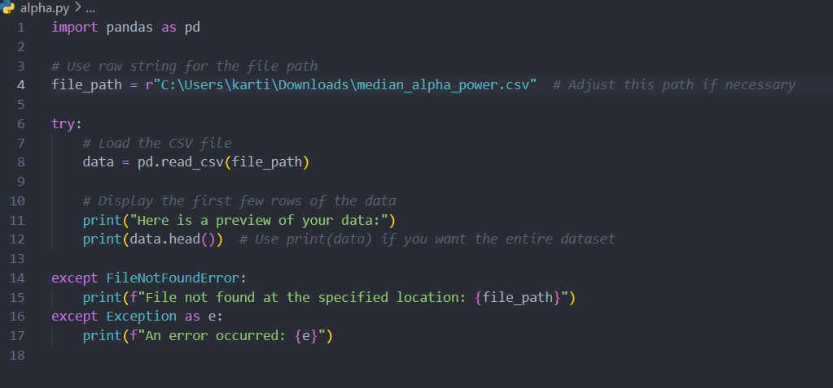

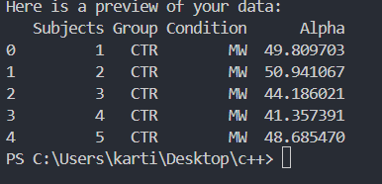

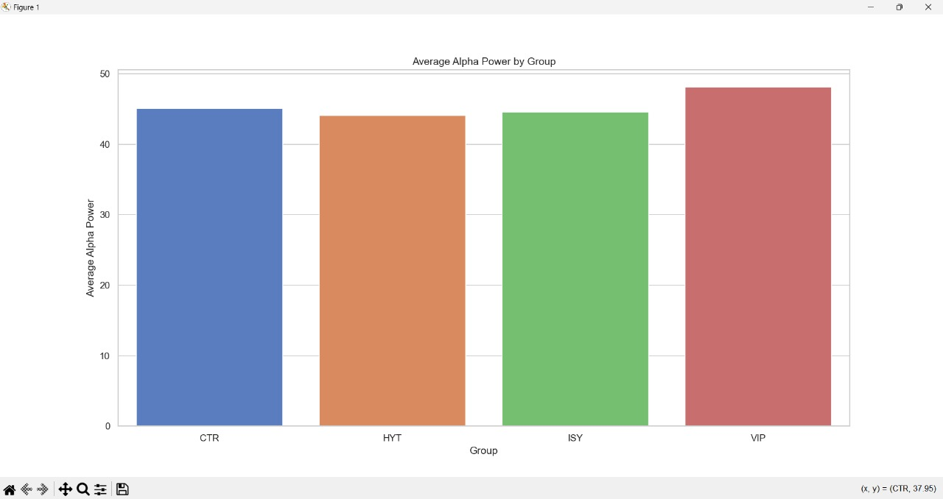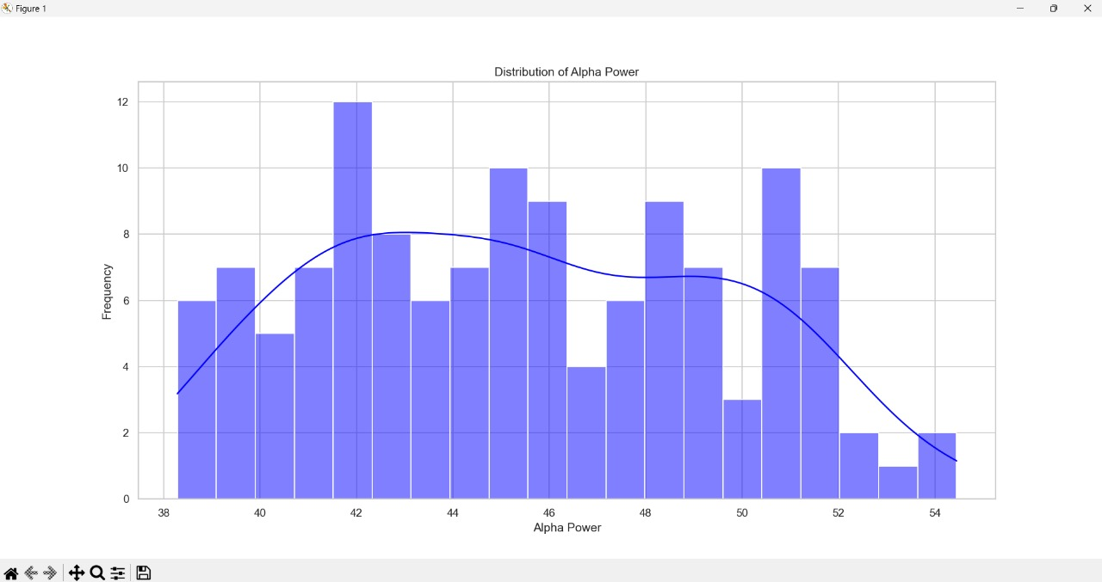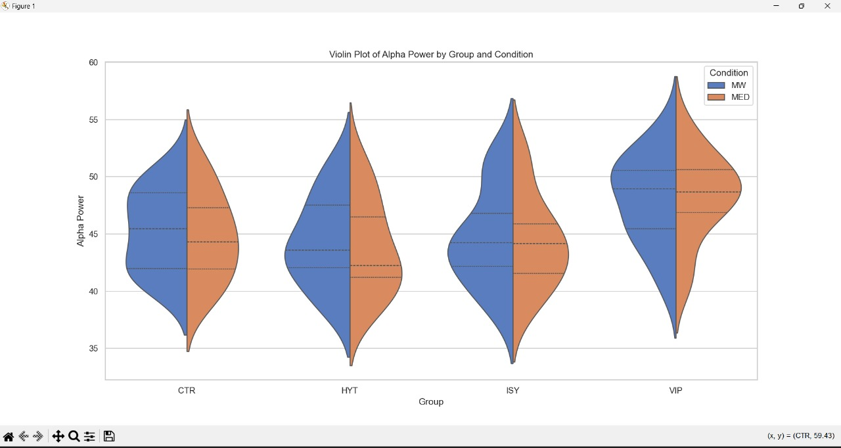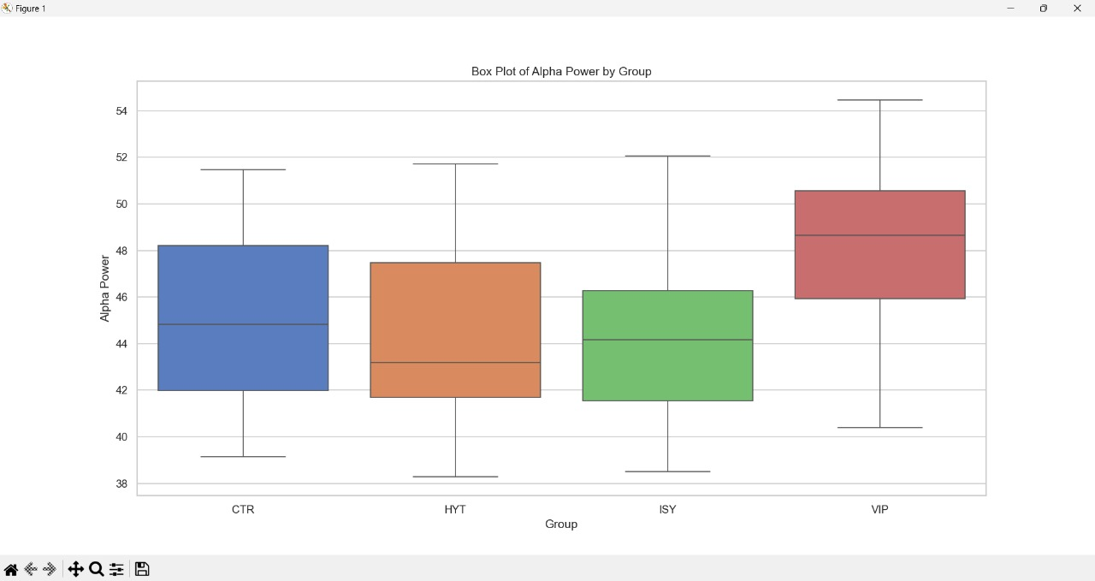

1. Import Libraries: Imports the necessary Python libraries: Pandas, Matplotlib, and Seaborn.

2. File Path: Defines the path to the CSV file using a raw string to avoid issues with backslashes.

3. Load Data: Reads the CSV file into a Pandas DataFrame using the file path.

4. Set Style: Configures Seaborn to use a white grid aesthetic for all plots.

5. Bar Chart: Creates a bar chart showing the average alpha power by group.

6. Histogram: Plots a histogram of the alpha power distribution with a density estimate.

7. Violin Plot: Generates a violin plot to visualize the distribution of alpha power by group and condition.

8. Box Plot: Displays a box plot to show the spread of alpha power by group.

IPL MATCHES

